**Summary of the history of the Zalcman family from Szydlow**

It was in July 1943 in Szydlow. The Germans discovered the place where the Zalcman family was hiding. They were hiding in the village of Kurozwęki - 7 km from Szydłów. They were a father, mother, two sons, a daughter and a grandmother.

They were led to the castle in Szydłów to be executed there. One of the sons, Symche Zalcman, took advantage of a moment of confusion on the part of the Germans and escaped The rest of the family was shot at the castle in Szydłów and buried there. Unfortunately, Symche Zalcman was killed by the Germans a few days later. The Zalcmans were exhumed in 2018, under the supervision of a rabbinical commission, and buried in the Jewish cemetery in Szydłów.

Currently, on their grave is only is only a modest wood gravestone. I think, that we should do a larger granite gravestone; and also a description of the Zalcman family history next to it. Then this tomb would appeal more, especially to younger generation.

Paweł Mazanka

[p.mazanka@uksw.edu.pl](mailto:p.mazanka@uksw.edu.pl)

<http://pawel.mazanka.com.pl/en>

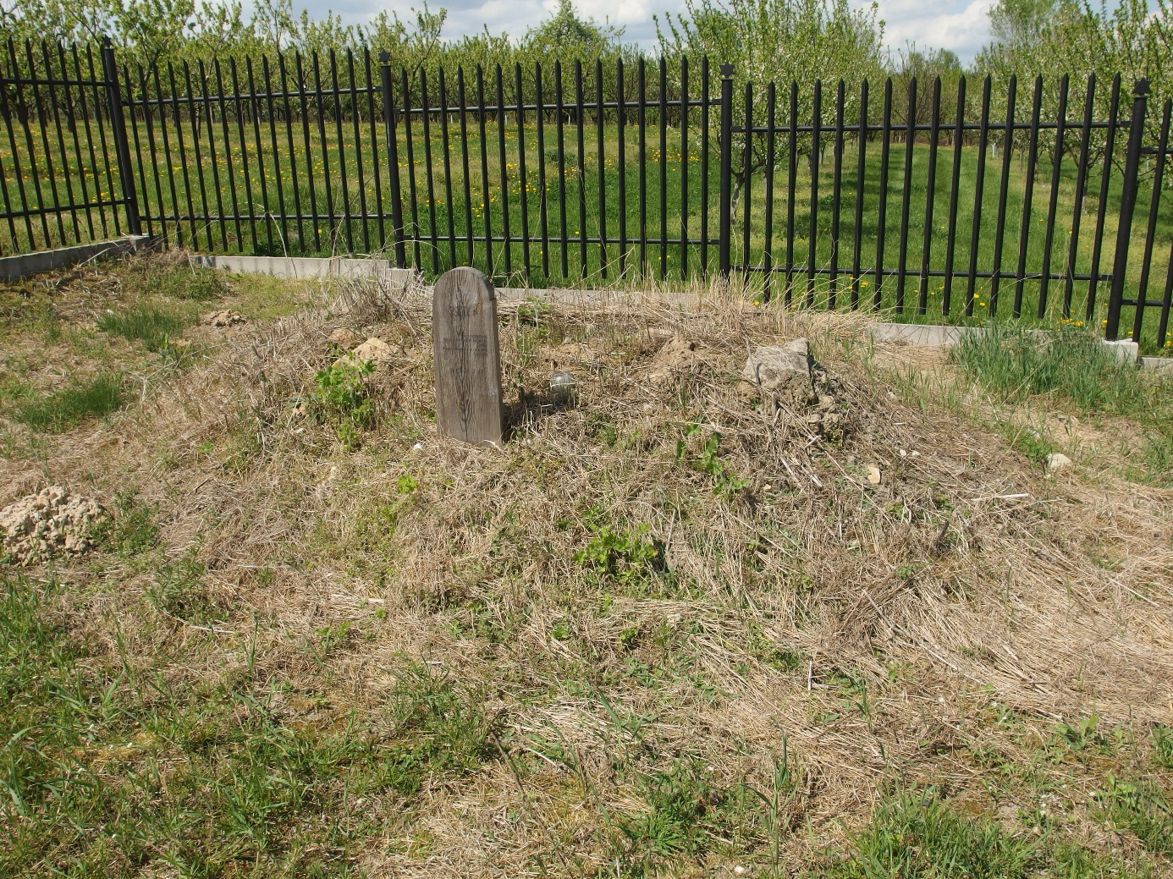

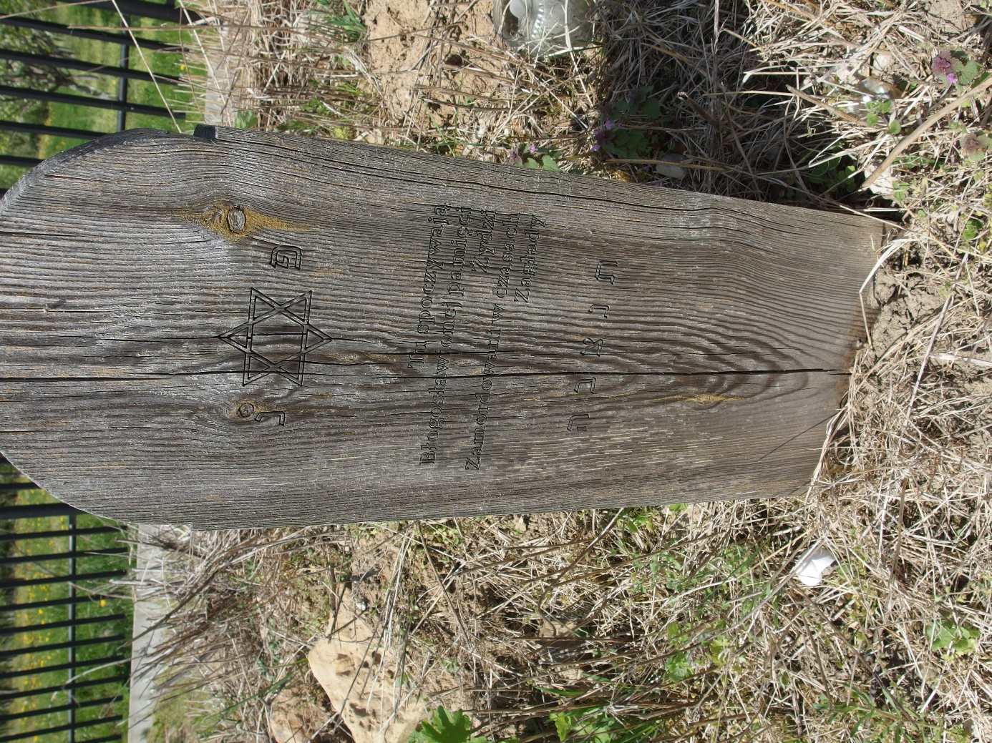

Szydlow gravestone of Zalcman family_2024